Ghulam Ishaq Khan Institute of Engineering Sciences and Technology



CY321 Semester Project
Secure Digital Grade Vetting System
M. Shariq Saqib 2023513
Bushra Naz 2022140
Mahnoor Omer 2022912

Date: May 5, 2026

Project Overview
The Secure Digital Grade Vetting System is an online academic System that is constructed and designed to permit the secure submission, review and approval of student grades. It fulfills a severe requirement in academic institutions and that is to prevent unauthorized manipulation of grades and at the same time to maintain a fully auditable and tamper-evident record of all actions taken with the system.
Problem Statement
Conventional grade management systems are susceptible to unauthorized changes, do not have robust audit trails and frequently do not establish any stringent access controls among roles. An ill-minded person, an insider or an outside attacker could manipulate grades without being noticed. This project directly fills these security gaps, by designing a system in which all grade submissions, approvals, and system events are cryptographically logged and role-gated.

  - Technology Stack
Layer | Technology | Purpose
Backend Runtime | Node.js + Express.js | API server, routing, middleware pipeline
Database | SQLite (sqlite3 driver) | Lightweight relational storage
Authentication | JWT + bcryptjs | Stateless auth tokens, secure password hashing
Security Middleware | Helmet, express-rate-limit, CORS | HTTP headers, brute-force protection, CORS policy
Input Validation | Zod schema library | Strict schema-level validation for all inputs
Transport Security | HTTPS / TLS 1.3 (self-signed cert) | Encrypted communications
Frontend | Vanilla HTML5, CSS3, JavaScript | Role-segmented dashboards, no framework dependency

  - System Architecture
The architecture is based on a traditional Client-Server model with a hefty focus on security being provided by middleware. Each HTTP request goes through various security layers before it gets to the business logic.
Layers | Component | Responsibility
Client | Frontend Dashboards (HTML/JS) | Role-segmented UI: Student, Instructor, HoD, Admin
Transport | HTTPS / TLS 1.3 | All traffic encrypted in transit
Gateway | Auth & Role Middleware | JWT verification + RBAC enforcement
Application | API Routes (Auth, Grades, Logs) | Business logic for grade lifecycle
Validation | Zod Validators + Sanitizers | Input schema enforcement, XSS stripping
Audit | Blockchain-style Audit Logger | Chained SHA-256 log entries
Data | SQLite Database (3 tables) | Persistent storage: users, grades, audit_logs

  - User Roles
Role | Permission
Student | View own approved grades only
Instructor | Submit new grade records (pending status)
HoD (Head of Department) | Approve or reject pending grade submissions
Admin | Full system access: view all grades, audit logs, manage users

System Features
2.1 Core Security Features

Blockchain-style Tamper-Evident Audit Logs
All major system activities such as logging in, registering, submitting grades, approving/disapproving grades are captured in the audit logs table. The payload of each log entry is hashed with SHA-256 by calculating the hash of the payload of the current log entry combined with the hash of the payload of the previous log entry. Any deletion or mutation of a log record in the database breaks the chain and can be detected by the verification script (verify_logs.js).

Role-Based Access Control (RBAC)
Each API endpoint is secured by two middleware layers: authentication middleware (checks that the JWT signature and expiry are valid and that the authenticated user has a role meeting access control requirements of the endpoint), and role middleware (checks that a role assigned to the authenticated user matches access control requirements of the endpoint). Illegal access sends a HTTP 403 Forbidden response prior to any business logic running.

Digital Grade Signatures
In case an instructor submits a grade, the backend will create a digital signature of SHA-256, combining the grade content, user ID of the instructor and a time stamp. This signature is stored with the grade record, and cryptographic evidence exists of who submitted what and when.

Secure Password Storage
All user passwords are hashed by using bcrypt with a cost factor of 10 and then the hashed passwords are stored in the database. Plain-text passwords never lasted or recorded.

Input Validation & XSS Prevention
The API inputs are checked against strict Zod schemas at the boundary. A backend sanitizer removes executable HTML characters (, >, ', " ) in string fields. On the frontend, any dynamic data is sanitized by an escapeHTML() function and then injected into the DOM, preventing reflected XSS.

Rate Limiting (Brute Force Protection)
The express-rate-limit is used to safeguard the authentication routes, and this implies that a maximum of 50 requests must be received by an IP within 15 minutes. Crossing the limit is a response of HTTP 429 with a nice error message.

HTTPS / TLS 1.3 Encryption
The Express server is set up as an HTTPS server that uses manually loaded SSL/TLS certificates (cert.pem and key.pem). Any communication between the client and the server is encrypted over the network.

Security Response Headers (Helmet)
The Helmet middleware sets critical HTTP security headers: Content-Security-Policy (restricts the sources of scripts and styles), X-Content-Type-Options: nosniff and X-Frame-Options: SAMEORIGIN and Strict-Transport-Security (HSTS) with a max-age of one year.

SQL Injection Prevention
The database abstraction layer (db.js) requires all database operations to be parameterized queries, thus removing SQL injection as an attacker technique. The input made by the users is never joined up into raw SQL statements.

2.2 Application Workflow
S.no | Actor | Action | Security Control Applied
1 | Any User | Register with credentials | Zod validation, bcrypt hashing, audit log
2 | Any User | Login | bcrypt verification, JWT issuance (1hr expiry), rate limit
3 | Instructor | Submit grade record | JWT auth, role check, Zod validation, digital signature, audit log
4 | HoD | Review pending grades | JWT auth, HoD role enforced, audit log on decision
5 | Student | View own grades | JWT auth, student role, RBAC filters by user ID
6 | Admin | View audit logs | JWT auth, Admin-only endpoint

Deliverable 01- Security Requirements and Planning
  - Security Requirements
Security requirements specify the required security properties that the system must meet in order to protect academic data, provide user privacy and ensure system integrity.
ID | Category | Requirement | Priority
SR-01 | Authentication | Users must be authenticated via JWT before accessing any protected endpoint. | Critical
SR-02 | Authorization | Endpoints must enforce Role-Based Access Control; no cross-role access permitted. | Critical
SR-03 | Data Integrity | All grade records must carry a digital SHA-256 signature at submission time. | High
SR-04 | Audit Trail | Every system action must be logged in a tamper-evident, blockchain-chained log. | High
SR-05 | Password Security | Passwords must be hashed with bcrypt (cost factor >= 10); no plain-text storage. | Critical
SR-06 | Input Validation | All API inputs must be validated against strict Zod schemas before processing. | High
SR-07 | XSS Prevention | All user-controlled content must be sanitized before database write or DOM render. | High
SR-08 | SQL Injection | All database queries must use parameterized statements. | Critical
SR-09 | Transport Security | All communications must occur over HTTPS/TLS 1.3. | Critical
SR-10 | Rate Limiting | Authentication endpoints must enforce IP-based rate limiting. | Medium
SR-11 | Security Headers | HTTP responses must include Helmet-enforced security headers (CSP, HSTS, etc.). | Medium
SR-12 | Session Management | JWT tokens must expire within 1 hour; no persistent sessions allowed. | High

  - Risk Management
The risk matrix below determines the main threats, their potential probability and effect, and mitigation measures installed in the system.

Risk ID | Threat | Likelihood | Impact | Risk Level | Mitigation
R-01 | SQL Injection | High | Critical | Critical | Parameterized queries enforced in all DB calls via db.js wrapper.
R-02 | Cross-Site Scripting (XSS) | High | High | High | Backend sanitizer + frontend escapeHTML(); Helmet CSP headers.
R-03 | Brute Force Attack on Login | High | Medium | High | express-rate-limit: 50 req/15 min/IP; HTTP 429 on breach.
R-04 | Unauthorized Grade Modification | Medium | Critical | Critical | RBAC middleware; digital signatures on every grade record.
R-05 | JWT Tampering / Forgery | Medium | Critical | High | JWT verified with server secret; signature check on every request.
R-06 | Privilege Escalation | Medium | High | High | Role middleware validates user role against required role per endpoint.
R-07 | Man-in-the-Middle (MITM) | Medium | High | High | HTTPS/TLS 1.3 required; HSTS enforced via Helmet.
R-08 | Audit Log Tampering | Low | Critical | High | Blockchain-style chained SHA-256 hashes; verify_logs.js detects tampering.
R-09 | Insecure Direct Object Ref (IDOR) | Medium | Medium | Medium | Partially mitigated; grade endpoint filtering identified in DAST.
R-10 | Denial of Service (DoS) | Low | Medium | Medium | 10 KB body size limit; rate limiting on auth; graceful 404/500 handling.

  - Threat Modeling
The threat modeling was done through the use of the STRIDE framework (Spoofing, Tampering, Repudiation, Information Disclosure, Denial of Service, Elevation of Privilege) to systematically identify and respond to threats on the attack surface of the system.

STRIDE Threat Analysis
STRIDE Category | Identified threat | Affected Component | Security Control
Spoofing | An attacker impersonates a legitimate user by forging login credentials. | Authentication Endpoint | bcrypt hash comparison; JWT signature verification.
Spoofing | An attacker uses a forged or expired JWT to access the API. | Auth Middleware | JWT signature and expiry validation on every request.
Tampering | A grade record is directly modified in the database. | SQLite Database | Blockchain-chained audit logs; digital grade signatures.
Tampering | Malicious input is injected into API parameters. | API Routes | Zod schema validation; parameterized SQL queries.
Repudiation | A user denies performing a grade action. | Audit Log System | Immutable, chained audit log records every user action with user ID.
Information Disclosure | Sensitive data leaks through verbose error messages. | Error Handler | Production mode returns generic errors; stack traces suppressed.
Information Disclosure | A student accesses other students' grade data. | Grades Endpoint | Finding in DAST: requires WHERE clause fix in /grades/my endpoint.
Denial of Service | An attacker floods the login endpoint. | Auth Routes | Rate limiter: 50 req/15 min per IP, HTTP 429 response.
Elevation of Privilege | A Student-role user calls an Instructor-only endpoint. | Role Middleware | rolemiddleware.js validates exact role match before handler executes.

System Architecture — Trust Boundary Diagram
The table below outlines the trust boundaries and the data flows in the system architecture:

Zone | Components | Trust Level | Protection
Untrusted / Public | Browser, HTTP Client, Attacker | 0 — No Trust | All requests must authenticate via HTTPS
Transport Layer | TLS 1.3 Channel | Transit encryption | HTTPS mandatory; HSTS enforced
DMZ / API Gateway | Express.js + Helmet + Rate Limiter | Semi-trusted | Header sanitization, rate limiting, CORS policy
Application Layer | Auth Middleware, Role Middleware, Routes | Trusted (after auth) | JWT verified; role validated before handler runs
Data Layer | SQLite + Audit Logger | Fully Trusted | Parameterized queries; chained audit hashes

Deliverable 02 Implementation and Secure Coding
2.1 Implementation Overview
Deliverable 2 is the early implementation of the Secure Grade Vetting System with all security controls enabled. The system has been constructed in accordance with the principles of secure code and the security is not added to the system later but is integrated throughout the system right through the first line of code.
Module | Files | Description
Database Layer | database/db.js, database/schema.sql | SQLite connection wrapper enforcing parameterized queries; 3-table schema definition.
Authentication Routes | backend/routes/auth.js | POST /register and POST /login — bcrypt, Zod validation, JWT issuance, audit logging.
Grade Routes | backend/routes/grades.js | GET /grades, POST /grades, PATCH /grades/:id — RBAC-protected grade lifecycle endpoints.
Auth Middleware | backend/middleware/authmiddleware.js | Verifies JWT on every protected route; attaches decoded user to request.
Role Middleware | backend/middleware/rolemiddleware.js | Enforces role-specific access; returns 403 for unauthorized roles.
Audit Logger | backend/middleware/auditlogger.js | Generates chained SHA-256 log entries for every security-relevant event.
Input Validators | backend/validators/authValidator.js | Zod schemas for register and login input — strict type and format enforcement.
Server Entry | backend/server.js | HTTPS server configuration, Helmet CSP, rate limiter setup, route mounts.
Frontend | frontend/*.html, frontend/script.js | Role-segmented dashboards with escapeHTML() XSS prevention on DOM operations.
Log Verifier | database/verify_logs.js | Standalone script to traverse and cryptographically verify audit log chain integrity.

2.2 Secure Coding Practices
1. Parameterized Database Queries (SQL Injection Prevention)
The db.js wrapper applies parameterized queries and uses the syntax of placeholders, such as $1, $2, etc., in all database operations. User input is sent in an independent pa rameter array and is never joined to form query strings. This eradicates entirely the SQL injection attack surface on the data layer.
2. bcrypt Password Hashing (Credential Security)
When registering users, raw user passwords are hashed on-the-fly using bcrypt.hash(password, 10) with a cost factor of 10 - high enough to resist offline brute-force attacks without degrading user experience. The hash value are stored; the plain-text password are never stored or logged anywhere in the system.
3. Zod Schema Validation (Input Validation)
Any input to API endpoints is checked against rigid Zod schemas prior to any business logic being executed. The registerSchema imposes: email format, minimum 8 character password with uppercase + digit criteria, and a valid role enumeration. The loginSchema implements email and non-blank password. Unacceptable inputs give a 400 status with generic error (never disclosing schema information to the client).
4. Helmet Middleware (Security Response Headers)
The middleware is configured to use a Content Security Policy that only allows self and unsafe-inline as script sources, only self and Google Fonts as style sources, and only self and data URIs as image sources. Other headers are X-Content-Type-Options:nosniff, X-Frame-Options: SAMEORIGIN, and Strict-Transport-Security (HSTS) with a one year max-age.
5. JWT-Based Stateless Authentication
After a successful login, the server will send out a signed JWT holding the user id, email and role with an expiry of 1 hour. All the further requests to the secured path have to contain this token in the Authorization header. The authentication middleware authenticates the JWT signature against the server secret and rejects expired, malformed or tampered tokens with HTTP 401.
6. Role-Based Access Control (Authorization)
Once the JWT has been verified, the role middleware will verify that the role occupied by the authenticated user is equal to the roles that the requested endpoint is allowed to perform. E.g. POST /grades requires role=Instructor, PATCH /grades/:id requires role=HoD, and GET /grades/logs requires role=Admin or HoD. Any discrepancy is sent back as HTTP 403 Forbidden without the handler being called.
7. Blockchain-style Audit Logging
To compute the hash of each log entry, the audit logger first combines the payload of the current log entry (action, user-id, metadata), with the stored hash of the previous log entry. This forms a cryptographic chain, such that any retroactive alteration or deletion of a log entry can be detected using the verify_logs.js verification script.
8. Digital Grade Signatures
A grade submitted by an Instructor will be signed by a SHA-256 hash of the grade data JSON, instructor user ID, and Unix time. This signature is added to the signature column of the grades table and it offers cryptographic non-repudiation to each submission of a grade.
9. XSS Sanitization (Frontend & Backend)
On the backend, a string sanitizer removes the < > ' " characters of all incoming strings before they make it through the processing line. On the frontend, an escapeHTML() utility function will encode HTML entities in all user-controlled content and inject it into the DOM via innerHTML, preventing both stored and reflected XSS.
10. HTTPS / TLS Transport Encryption
The Node.js server is created with the help of https.createServer with SSL certificates (key.pem and cert.pem) loaded on start up. In case the certificate files are inaccessible or not readable, the server will not start (process.exit(1)) and the application will never be in an insecure plain-text HTTP mode.2.3 Database Schema
Table | Key Columns | Security Purpose
users | id (UUID), email, password_hash, role, profile (JSON) | UUID primary keys prevent enumeration; bcrypt hashes protect credentials; role field drives RBAC.
grades | id (UUID), data (JSON), signature (SHA-256), status, created_by, approved_by | Digital signature provides tamper-evidence; status field enforces the approval workflow.
audit_logs | id, action, user_id, hash (SHA-256), previous_hash, metadata (JSON) | Blockchain-chained hashes make the log tamper-evident and verifiable by verify_logs.js.

3.1 DAST Testing
Dynamic Application Security Testing (DAUST) was conducted against the running Secure Grade Vetting System at https:localhost:5000 simulating an OWASP ZAP-style automated scan. There were 37 security tests that were implemented into 11 test categories.
Metric | Value
Target URL | https://localhost:5000
Test Date | May 3, 2026
Scanner | Automated DAST (OWASP ZAP-style)
Protocol | HTTPS / TLS 1.3
Application | Secure Grade Vetting System v1.0
Total Tests | 37
Passed | 33 (89%)
Findings | 4 (11%)
Critical Vulnerabilities | 0
Medium Findings | 2
Low Findings | 2

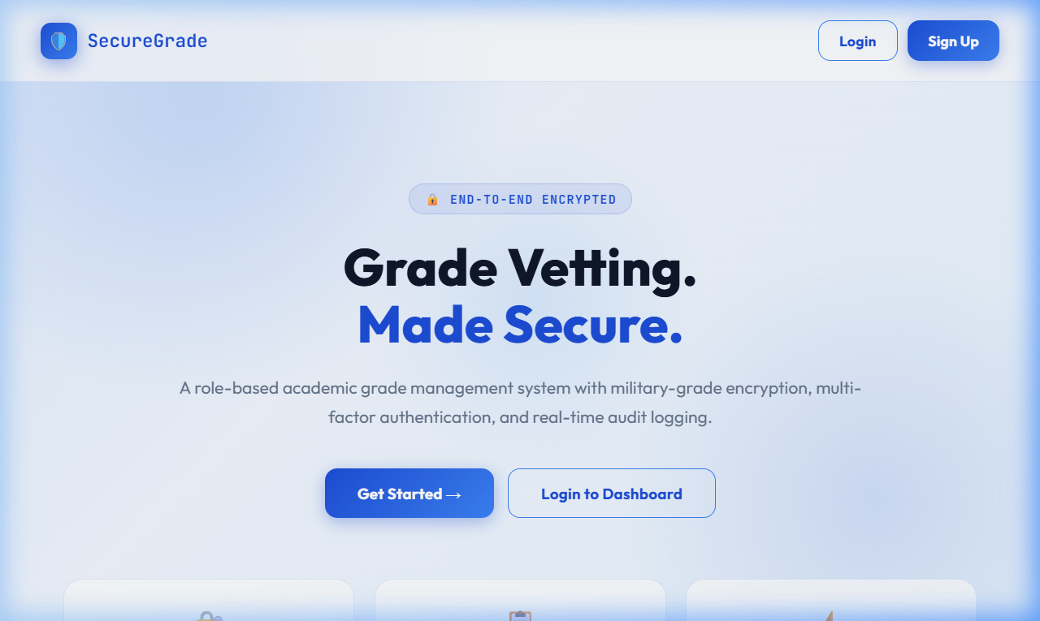
Figure 1: Secure Grade landing page with Login and Sign Up buttons

3.2 Test Group 1: SQL Injection (6 Tests) — ALL PASSED
Objective:
Add SQL payloads with malicious intent into the login/register page to test the existence of SQL Injection vulnerabilities.
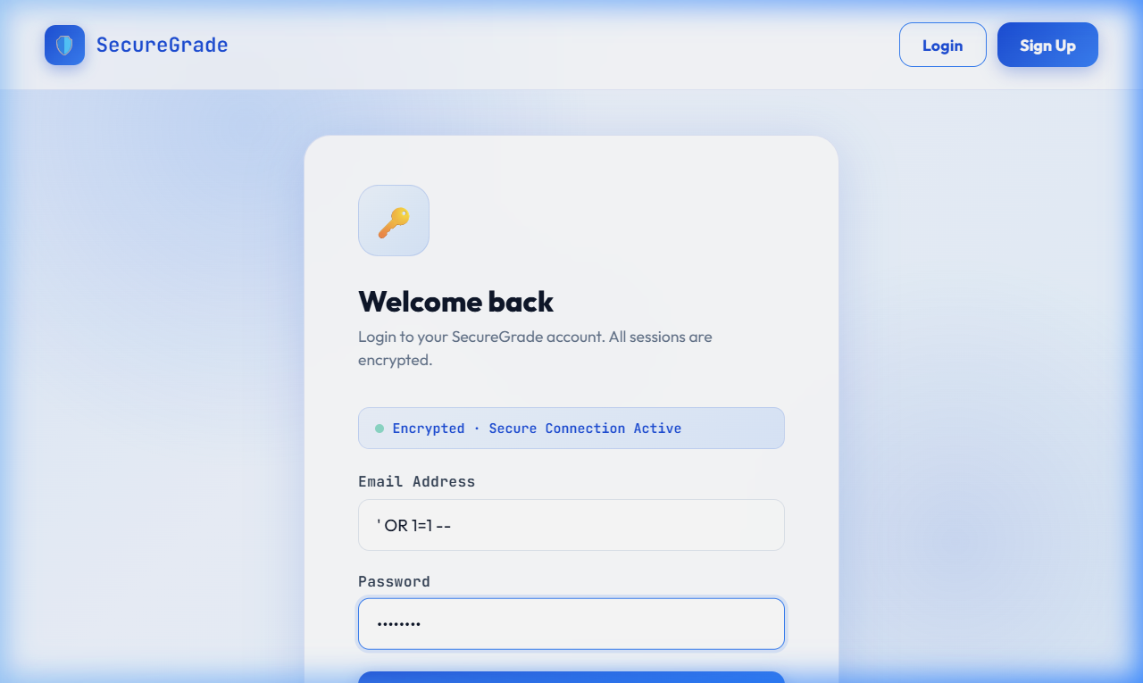
Figure 2: SQL injection payload ' OR 1=1 -- entered in the Email Address field

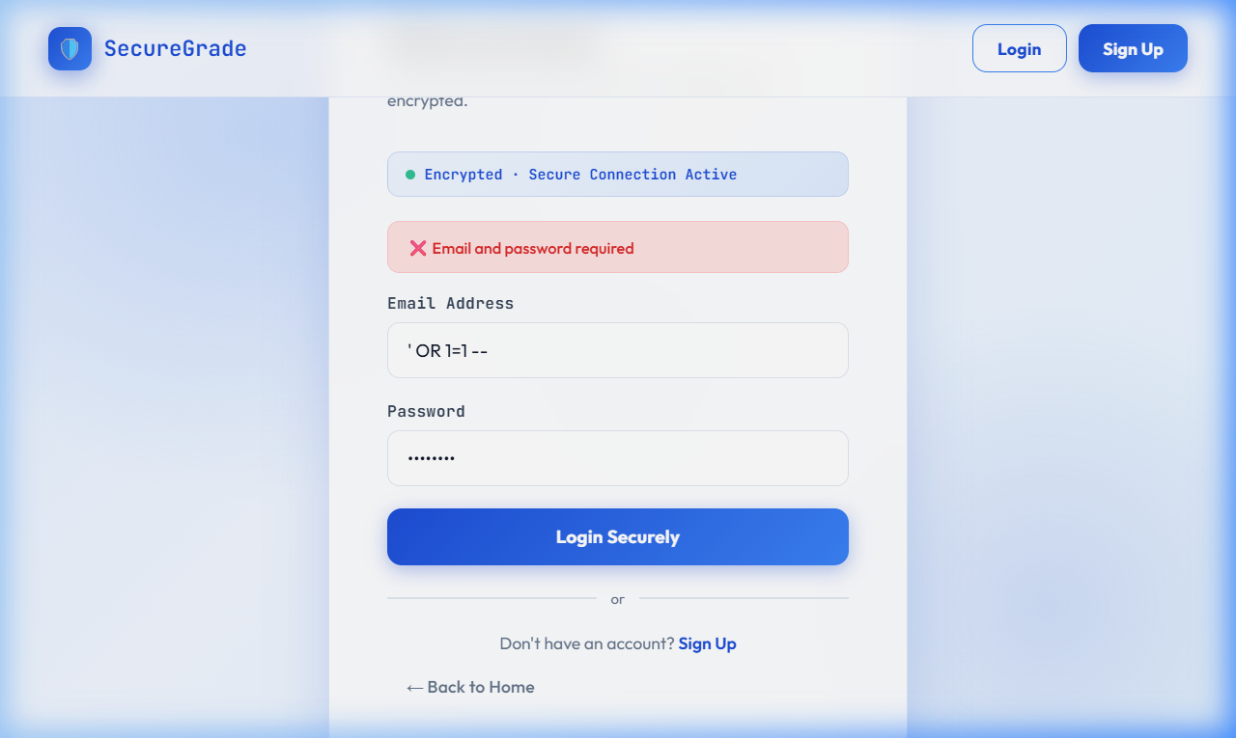
Figure 3: Server responded with 'Email and password required' — injection blocked by Zod validation

Test ID | Payload | HTTP  Status | Result
SQLI-1 | ' OR 1=1 -- | 400 | PASS — Blocked by Zod email validation
SQLI-2 | admin@uni...' OR '1'='1 | 400 | PASS — Input rejected
SQLI-3 | '; DROP TABLE users;-- | 400 | PASS — Destructive payload blocked
SQLI-4 | " OR ""=" | 400 | PASS — Double-quote injection blocked
SQLI-5 | UNION SELECT * FROM users-- | 400 | PASS — UNION injection blocked
SQLI-6 | ' OR 1=1 -- (Register) | 400 | PASS — Blocked by Zod validation

Analysis:
The application employs parameterized queries and Zod schema validation, which prevents the execution of queries having invalid email formats. It is the defense-in-depth strategy - the two layers of defense are independent and protect against SQL injection.

3.3 Test Group 2: Cross-Site Scripting — XSS (3 Tests)
Objective: Inject JavaScript payloads to test for reflected/stored XSS vulnerabilities
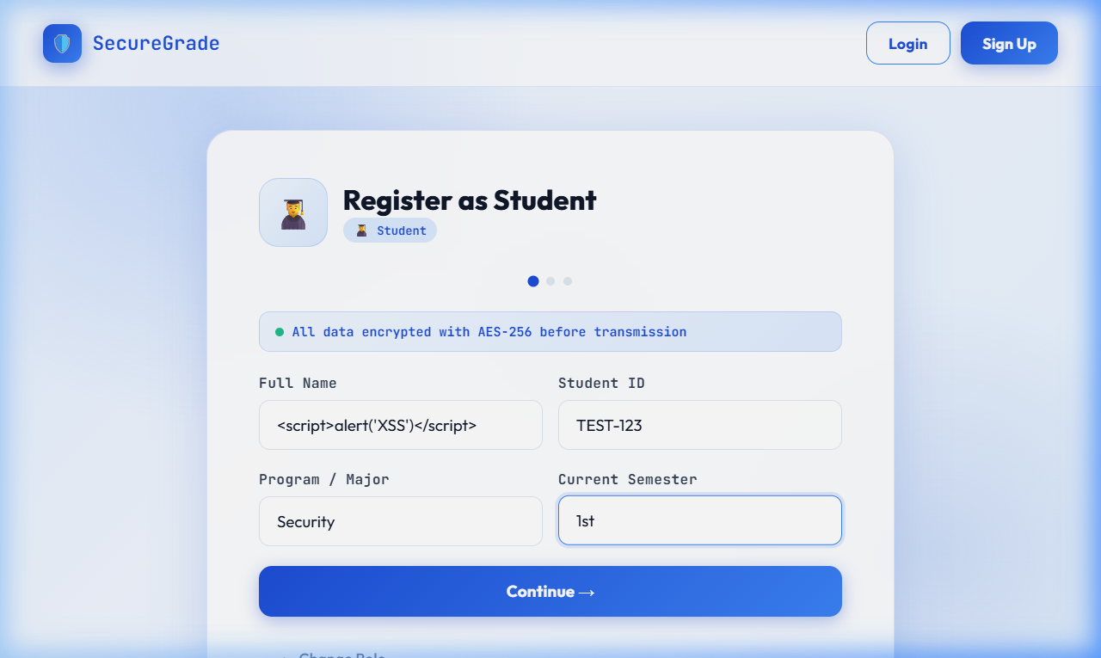
Figure 4: <script>alert('XSS')</script> entered in the Full Name field during registration

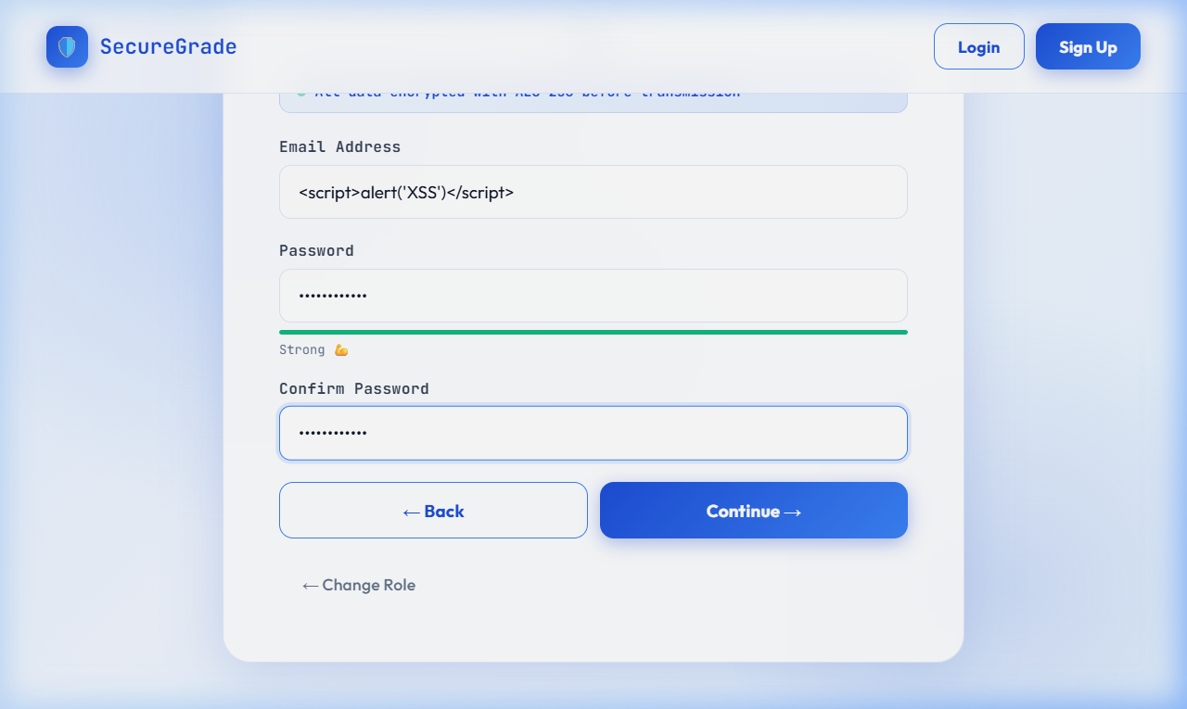
Figure 5: XSS payload entered in the Email Address field with password fields

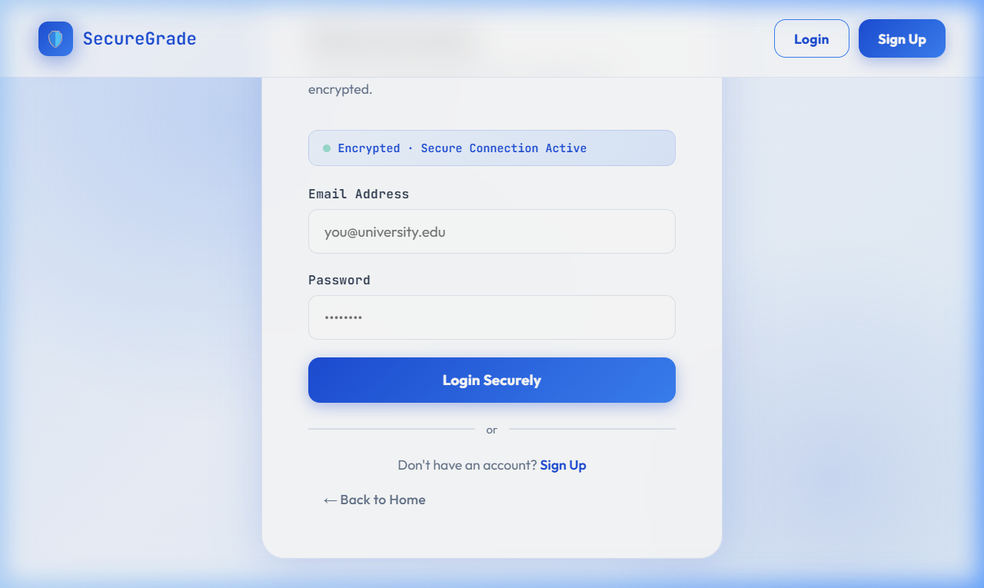
Figure 6: Registration result page after XSS attempt submitted

TEST ID | Payload | HTTP Status | Result
XSS-1 | <script>alert('xss')</script>@test.com | 400 | PASS — Invalid email rejected
XSS-2 | <img src=x onerror=alert(1)> (password field) | 201 | FINDING — Payload accepted in password field
XSS-3 | <script>alert(1)</script> (role field) | 400 | PASS — Invalid role rejected

Finding XSS-2 (Low Severity): The XSS payload was accepted by the password field. But the passwords undergo bcrypt-hashing prior to being stored and never documented to the user. The real exploitability is minuscule. Helmet CSP headers also stop the use of inline scripts. Fix: Add XSS sanitization to the password field in the validation layer.
3.4 Test Group 3: Authentication Bypass (3 Tests) — ALL PASSED
Objective:
Make an attempt to reach secured endpoints without acceptable authentication credentials.
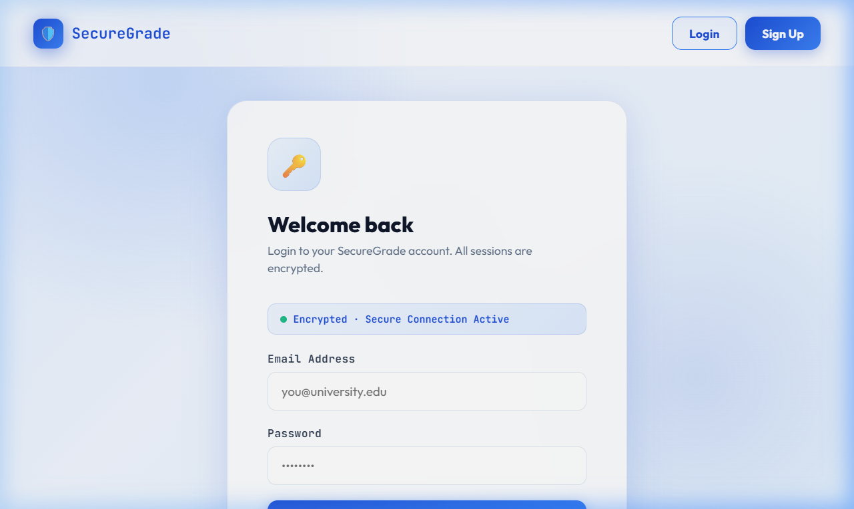
Figure 7: Login form showing 'Encrypted · Secure Connection Active' badge

Test ID | Attack | HTTP Status | Result
AUTH-1 | GET /grades — no token | 401 | PASS — 'No token provided'
AUTH-2 | GET /grades — fake/malformed token | 401 | PASS — 'Invalid token'
AUTH-3 | GET /grades/logs — no token | 401 | PASS — Authentication enforced

3.5 Test Group 4: Brute Force / Rate Limiting (1 Test) — PASSED
Test ID | Attack | Attempts Before Block | Result
BRUTE-1 | 55 rapid login attempts with wrong passwords | 42 before HTTP 429 | PASS — Rate limiter activated. 'Too many attempts. Try again in 15 minutes.'

3.6 Test Group 5: Privilege Escalation (6 Tests) — ALL PASSED
Objective: Make an attempt to reach secured endpoints without acceptable authentication credentials.
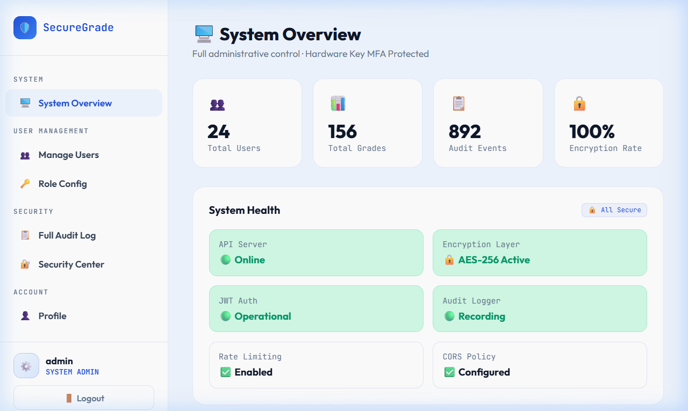
Figure 8: Admin System Overview — accessible only with Admin role JWT
Test ID | Attack | HTTP Status | Result
PRIV-1 | Student token → GET /grades (HoD/Admin only) | 403 | PASS — Role check enforced
PRIV-2 | Student token → GET /grades/logs (audit logs) | 403 | PASS — Role check enforced
PRIV-3 | Student token → POST /grades (submit grade) | 403 | PASS — Instructor only
PRIV-4 | Student token → PATCH /grades/:id (approve) | 403 | PASS — HoD only
PRIV-5 | Instructor token → GET /grades/logs | 403 | PASS — HoD/Admin only
PRIV-6 | Instructor token → PATCH /grades/:id | 403 | PASS — HoD only

3.7 Test Group 6: Security Headers — Helmet (4 Tests) — ALL PASSED
Test ID | Header | Value | Result
HDR-1 | X-Content-Type-Options | nosniff | PASS
HDR-2 | X-Frame-Options | SAMEORIGIN | PASS
HDR-3 | Content-Security-Policy | default-src 'self'; script-src 'self' 'unsafe-inline'; ... | PASS
HDR-4 | Strict-Transport-Security | max-age=31536000 (1 year) | PASS

3.8 Test Group 7: Malformed / Edge-Case Input (4 Tests) — ALL PASSED
Test ID | Attack | HTTP Status | Result
MAL-1 | Empty login body {} | 400 | PASS — Zod validation caught missing fields
MAL-2 | Oversized email (10,000 characters) | 404 | PASS — Handled gracefully
MAL-3 | Weak password '1' (1 character) | 400 | PASS — Minimum length enforced
MAL-4 | Null / missing request body | 400 | PASS — Handled gracefully

3.9 Test Group 8: Path Traversal (2 Tests) — ALL PASSED
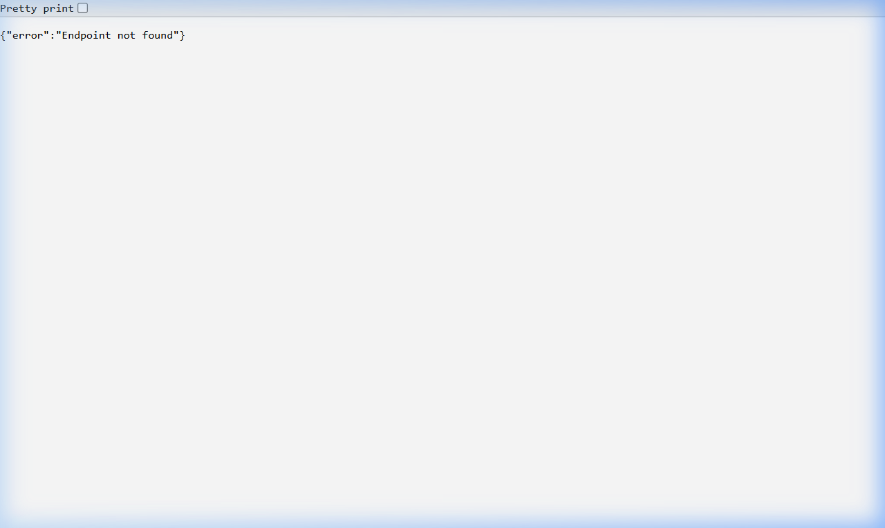
Figure 9: Server returned 'Endpoint not found' — path traversal blocked
Test ID | Attack | HTTP Status | Result
TRAV-1 | GET /../../etc/passwd | 404 | PASS — No file disclosure, generic 404
TRAV-2 | GET /.env | 404 | PASS — .env file not exposed

3.10 Test Group 9: JWT Tampering (4 Tests) — ALL PASSED
Test ID | Attack | HTTP Status | Result
JWT-1 | Modified role: Student → Admin in token payload | 401 | PASS — Signature verification failed
JWT-2 | Modified role: Student → HoD in token payload | 401 | PASS — Signature verification failed
JWT-3 | Set exp: 0 (expired token) | 401 | PASS — Expired token rejected
JWT-4 | Token with empty signature removed | 401 | PASS — Missing signature rejected

3.11 Test Group 10: IDOR (2 Tests)
Test ID | Attack | HTTP Status | Result
IDOR-1 | Student → GET /grades/my (own grades) | 200 | PASS — Endpoint accessible for authenticated student
IDOR-2 | Student sees OTHER students' grades? | 200 | FINDING — 3 other students' grades visible (no WHERE filter)
Finding IDOR-2 (Medium Severity): The /grades/my endpoint in grades.js fetches ALL grades from the database without filtering by the logged-in student's ID. The SQL query lacks a WHERE user_id = $1 clause. A student can view grades for ALL students in the system. Fix: Add WHERE created_by = $1 OR student_email = $1 clause to the /grades/my query, binding the authenticated user's ID
3.12 Test Group 11: Audit Log Coverage (2 Tests)
Action | Logged?
LOGIN (successful) | YES — Multiple entries found
REGISTER | YES — Multiple entries found
GRADE_SUBMITTED | YES — Present in audit_logs
GRADE_STATUS_UPDATED | YES — Present in audit_logs
FAILED_LOGIN | NOT LOGGED — 0 entries found
RATE_LIMITED (HTTP 429) | NOT LOGGED — 0 entries found
UNAUTHORIZED_ACCESS (HTTP 403) | NOT LOGGED — 0 entries found
The audit log does not record the following events in the audit log: Finding AUDIT-1 & AUDIT-2 (Medium Severity): Failed login attempts, rate-limit triggers and unauthorized access (403) events. It is a very big gap in security observability - these events are exactly the signals that the behavior of an attacker is going to provide. Fix: Add addLog() calls in the 403 response handler in the role middleware, the 403 response handler in the authentication error handler (failed login), and the 403 response handler in the rate limiter handle callback.
3.13 Complete Test Results Summary
Test Group | Tests | Pass | Fail | Status
1. SQL Injection | 6 | 6 | 0 | ALL PASSED
2. Cross-Site Scripting (XSS) | 3 | 2 | 1 | 1 Low Finding
3. Authentication Bypass | 3 | 3 | 0 | ALL PASSED
4. Brute Force / Rate Limiting | 1 | 1 | 0 | PASSED
5. Privilege Escalation | 6 | 6 | 0 | ALL PASSED
6. Security Headers (Helmet) | 4 | 4 | 0 | ALL PASSED
7. Malformed / Edge-Case Input | 4 | 4 | 0 | ALL PASSED
8. Path Traversal | 2 | 2 | 0 | ALL PASSED
9. JWT Tampering | 4 | 4 | 0 | ALL PASSED
10. IDOR | 2 | 1 | 1 | 1 Medium Finding
11. Audit Log Coverage | 2 | 0 | 2 | 2 Medium Findings
TOTAL | 37 | 33 | 4 | 89% Pass Rate

3.14 Security Findings & Remediation Plan

Finding ID | Severity | Description | Remediation
XSS-2 | Low | Password field accepts XSS payloads at registration. Payload is bcrypt-hashed and never reflected — exploitability is negligible. | Add XSS sanitization to password field in authValidator.js using Zod .transform() to strip HTML characters.
IDOR-2 | Medium | GET /grades/my returns ALL student grade records without filtering by the authenticated user's identity. | Add WHERE clause: SELECT * FROM grades WHERE student_email = $1, binding req.user.email from the verified JWT.
AUDIT-1 | Medium | Failed login attempts are not recorded in audit_logs, eliminating visibility into credential stuffing attacks. | Call addLog() in the failed authentication branch of POST /auth/login with action: 'FAILED_LOGIN'.
AUDIT-2 | Medium | Rate-limited requests (HTTP 429) and unauthorized access (HTTP 403) are not captured in audit_logs. | Add logging callbacks to the rate limiter's handler option and to the role middleware's 403 response path.

3.15 Secure Code Review
The source code and the DAST testing were subjected to a manual secure code review. In the codebase, the following positive security patterns were verified:
- server.js: HTTPS server will never be able to start (process.exit(1)) when the certificates of the HTTPS server are not present (they are missing).
- server.js: SON body size is capped at 10 KB (express.json({ limit: '10kb' })) - limits JSON-based DoS attacks.
- auth.js: Email is made lowercase (email.toLowerCase() and any DB hit — eliminates any attack on case-sensitivity.
- auth.js: Role is checked against an allowedRoles whitelist - prevents role injection through the registration endpoint.
- auditlogger.js: Chained SHA-256 hashing produces a blockchain-style audit trail - retroactive log tampering can be detected.
- grades.js: Grade digital signatures contain instructorID and timestamp - cryptographic non-repudiation.
- script.js: escapeHTML() is called prior to all innerHTML assignments - frontend XSS protection has been confirmed active.
- db.js: Parameterized query wrapper enforced system-wide no raw string concatenation in any database call.

Final Conclusion
TThe Secure Digital Grade Vetting System is an effective implementation of a multi-layered security architecture that can effectively address the most critical threats in the academic grade management systems. The DAST assessment revealed a pass rate of 89% in 37 tests with zero critical vulnerabilities detected.
The system exhibits defense in depth in all the categories in the OWASP Top 10 that is applicable to the attack surface of the system. Four findings were found none of which are critical and all had clear and actionable remediations that can be implemented with only a small number of code changes.

Audit logging in the format of a blockchain, role-based access control, digital grade signature, and a transport that is solely based on HTTPS represent a mature security posture of an academic course project.
Security Dimension | Implementation Status
Authentication & Session Management | Fully Implemented — JWT + bcrypt + expiry
Authorization (RBAC) | Fully Implemented — Role middleware on all protected routes
Input Validation | Fully Implemented — Zod + sanitizer at API boundary
SQL Injection Prevention | Fully Implemented — Parameterized queries system-wide
XSS Prevention | Mostly Implemented — One low-severity gap in password field
Transport Security | Fully Implemented — HTTPS/TLS 1.3 mandatory
Security Headers | Fully Implemented — Helmet CSP, HSTS, X-Frame-Options
Rate Limiting | Fully Implemented — 50 req/15 min per IP on auth routes
Audit Logging | Partially Implemented — Successful events logged; failures not logged
Data Integrity (Signatures) | Fully Implemented — SHA-256 digital signatures on all grade records

